PAGE 1 — P2P FILE SHARING (BITTORRENT)
Topic: Understand how P2P file sharing works
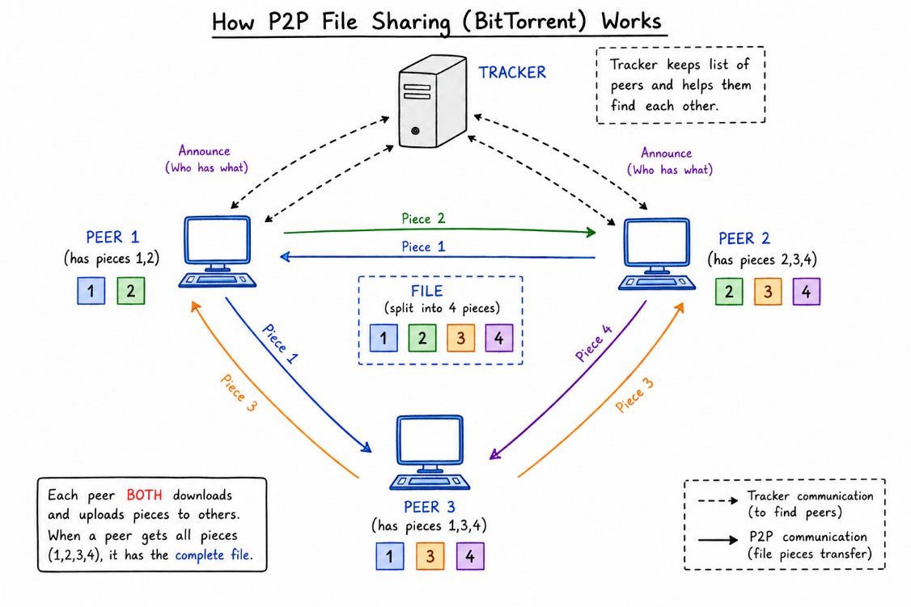
What I did: I reviewed the P2P/BitTorrent diagram showing peers, the tracker, and file pieces.
Explanation: The diagram explains that peers announce what pieces they have and exchange pieces directly until the complete file is available.

PAGE 2 — WINDOWS INSTALLATION
Topic: Install the required Windows components
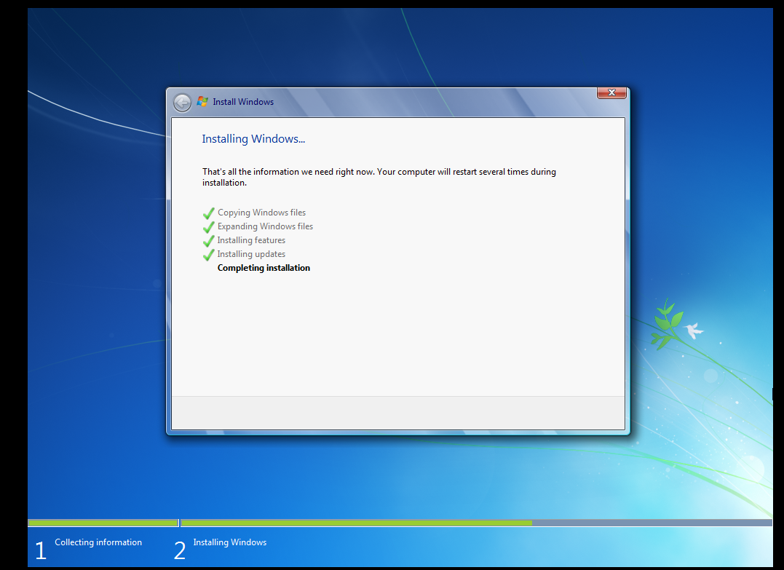
What I did: I proceeded through the Windows installation process shown on the screen.
Explanation: The setup progress indicates that Windows components are being installed on the system.

PAGE 3 — WINDOWS STARTUP
Topic: Start the Windows system
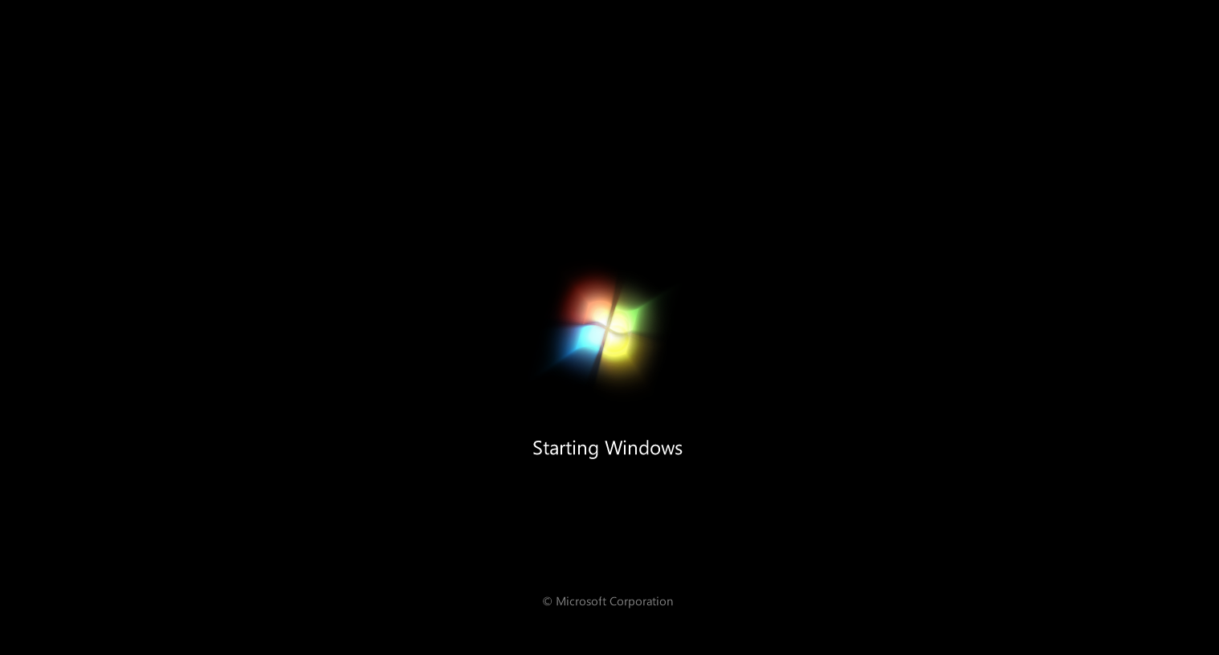
What I did: I started the Windows system and waited for the operating system to load.
Explanation: The startup screen confirms that Windows is booting and preparing the desktop environment.

PAGE 4 — WINDOWS COMMAND PROMPT
Topic: Check the IP configuration
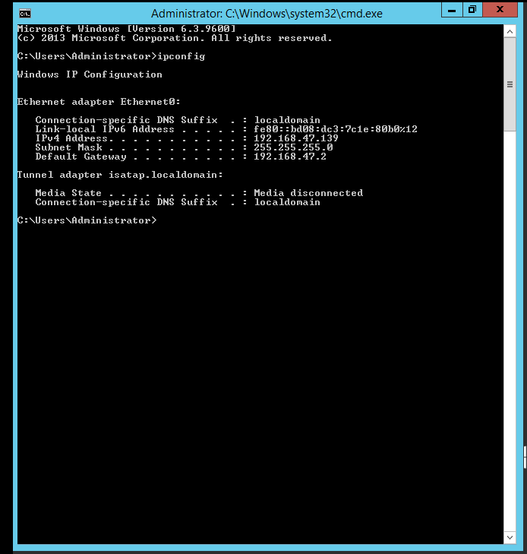
What I did: I opened the Administrator Command Prompt and ran ipconfig to view the network configuration.
Explanation: The command displays the IPv4 address, subnet mask, and default gateway of the Windows system.

PAGE 5 — WINDOWS COMMAND PROMPT
Topic: Check the second system IP configuration
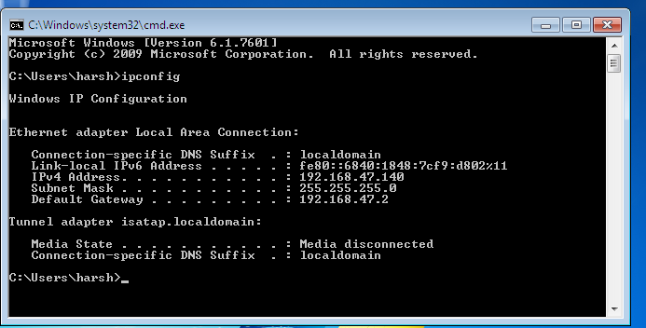
What I did: I ran ipconfig on the other Windows system to identify its IPv4 network address.
Explanation: The output shows the system's IPv4 address and network settings that can be used for connectivity testing.

PAGE 6 — WINDOWS FIREWALL
Topic: Review Windows Firewall status
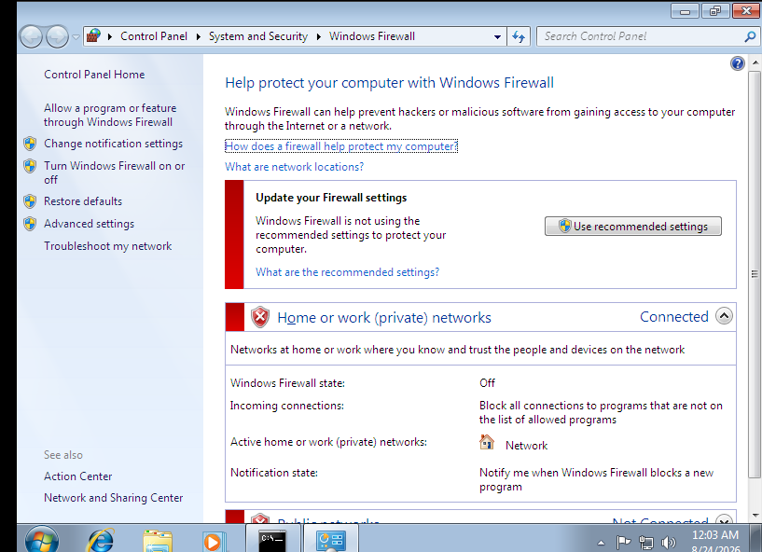
What I did: I opened Windows Firewall from Control Panel and checked its current status.
Explanation: The screen shows the firewall state and the network profile currently being used by Windows.

PAGE 7 — WINDOWS FIREWALL
Topic: Review private network firewall settings
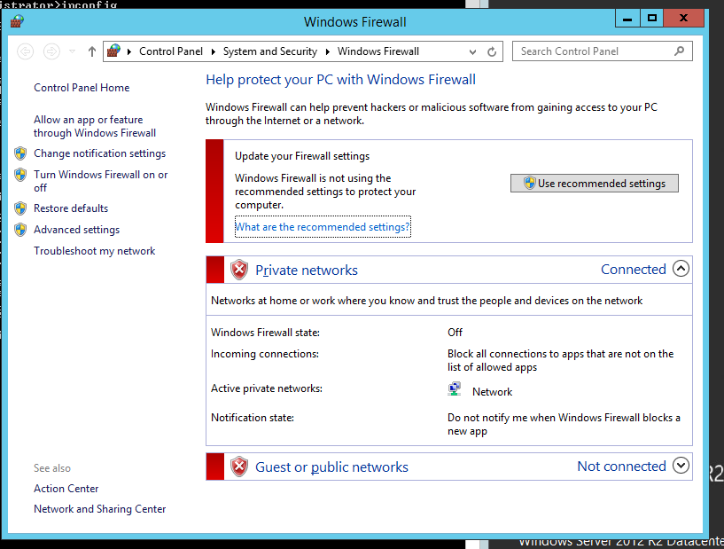
What I did: I reviewed the Windows Firewall settings for the connected private network.
Explanation: The private-network profile and its current firewall/connection settings are displayed for verification.

PAGE 8 — NETWORK TESTING
Topic: Ping the remote system
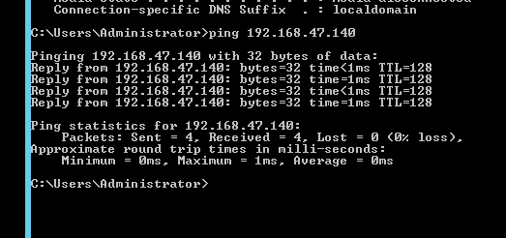
What I did: I used ping to test connectivity to the remote IP address from the command prompt.
Explanation: The successful replies confirm that the remote system is reachable over the network.

PAGE 9 — NETWORK TESTING
Topic: Ping the other system
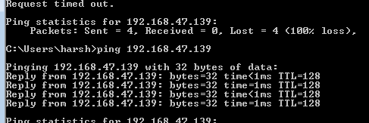
What I did: I ran ping against the other IP address to verify network connectivity.
Explanation: The replies received from the target address confirm that communication between the systems is working.

PAGE 10 — WINDOWS SYSTEM SETTINGS
Topic: Review Windows system settings
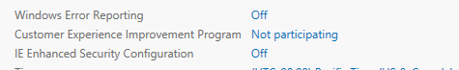
What I did: I reviewed the Windows system configuration and the available security/management settings.
Explanation: These settings are checked as part of preparing the Windows environment for the required networking and application work.

PAGE 11 — PYTHON FOR WINDOWS
Topic: Open the Python download page
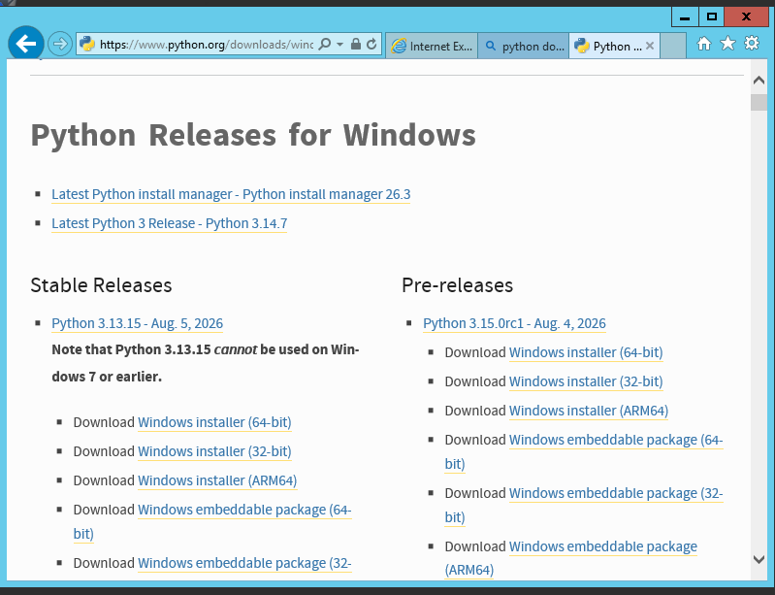
What I did: I opened the Python Releases for Windows page to obtain the required Python installer.
Explanation: The page lists the available Python releases and Windows installer options.

PAGE 12 — PYTHON INSTALLATION
Topic: Install Python
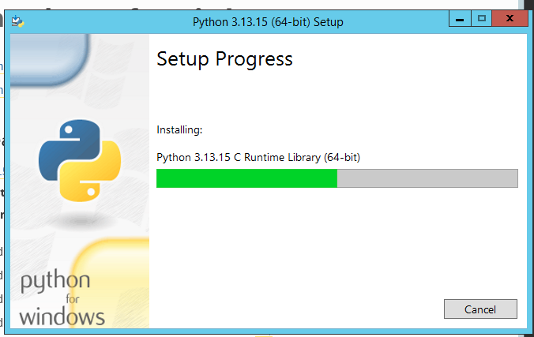
What I did: I started the Python installer and allowed the setup process to continue.
Explanation: The setup progress shows that Python and its required components are being installed.

PAGE 13 — PYTHON ENVIRONMENT
Topic: Verify Python and create the project folder
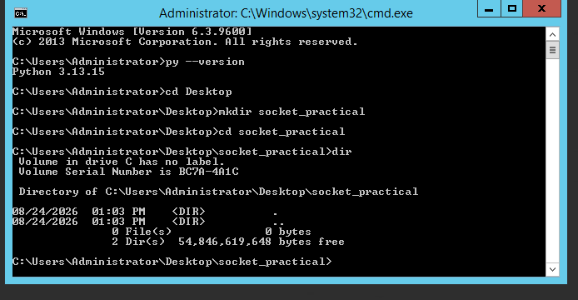
What I did: I checked the installed Python version, moved to the Desktop, created the socket_practical folder, and listed its contents.
Explanation: The command output confirms Python 3.13.15 is available and the socket_practical working directory has been created.

